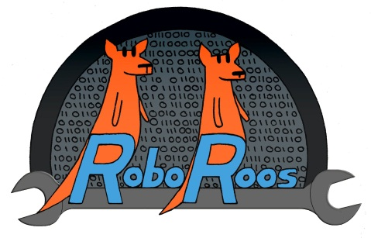
Newsletter July 2014

DDU REPORTS
I’m not sure how many of you actually watched the live streams that were running all last weekend for DDU, but for those who don’t know already, we came 2nd in the finals!!!!
The way the finals worked was best of three. They won the first game, we won the second, and then it was down to the last match. SO CLOSE. Things didn’t really go so well for any team in the last round on the field especially us, as our pneumatics system was broken by our opposition so our BAS wasn’t operational……
With all the things that went wrong in that match for us, we could have requested a re-run, but our alliance partners and our team decided to use our gracious professionalism and give them the win as one of their robots broke completely and wouldn’t have been able to drive at all. We didn’t think it would be fair if we did request a rematch.
This is why DDU was so good, because all the teams are not in it to necessarily win, but to help others out, be fair and make long lasting friends within all the teams. I think everyone in the DDU team had an amazing time and met some incredible new people who we can’t wait to see again at the first ever Australian Regionals next year!
The team worked so well together, even though we didn’t get that much sleep as it was late nights and early mornings for us to get the robot finished (and then fixed, over and over) – and of course mixed in were a few chocolate magnums, rounds of cards and ping pong games! I’m really proud of the way we performed in Sydney, and I think everyone else should be proud too. -Emily Mansfield
Since the Hawaii regional we have had the opportunity to redesign our robot completely. And redesign we did! There is barely anything on the robot that is the same. From the base to the ball acquisition system (BAS), from the shooter to the pneumatics!
We have met many different teams from interstate and even one from China who had awesome dance moves.
During the alliance selections we were asked by the second ranking team TDU II 5331 to join them in the finals, which we graciously accepted. The third team on our alliance was Cockatoo Crew, team 8142. We won all of our preliminary and semi-final matches and got into the grand final which was best of three. All three games were so intense we couldn’t sit down. Unfortunately the third deciding match went against us but we had so much fun getting there. -Ali McDonald
LEAD MENTOR REPORT
Another busy build season, leading to a great competition with a robot that could pick up, pass, shoot and drive fast. A big thanks to our mentors, especially Geoff, Ivan and Adam and our build sheds at Donna’s, Lindy’s and Trevor’s. The students could not have achieved so much without your help. Rob
MANAGEMENT REPORT
Congratulations to the WHOLE FRC team for a wonderful re-build, great team spirit and a successful tournament in Sydney. This lays a great foundation for the upcoming "training season" and then the next build kicking off in January with the inaugural Australian FIRST FRC competition being held at Sydney Olympic Park from March 10-12th.
On team matters, please look out for a notice to the Annual General Meeting, which we are targeting to have around the same time as Science Week and our Open Day - and of course get both of these events in your diaries also. At the AGM we will communicate some of the developments on both the management and technology side that will make RoboRoos even more effective in delivering the wonderful platform that FIRST provides.
Amongst other things we need more student members to share the load and bring new skills and interests. So, if you know of fellow students who may be interested please introduce them. We have gaps across pretty much every discipline - web design and management, event management, media engagement and outreach, design and cad, software, electrical and mechanical.
Also, I look forward to seeing and hearing our FLL team swing into action in the next few weeks - can we top the State again? -Peter Ryan-Kane, Commercial Mentor
CAPTAIN’S REPORT
I tuned into the live stream of the DDU and would first of all like to congratulate the RoboRoos and their alliance partners TDU II and the Cockatoo Crew for making it into the finals. Of course I would also like to extend this congratulations for all teams involved in the Duel Down Under this year; as always it is clear that everyone made a fantastic effort.
We recently got the team together for a group photo with “Marvin Mark Two” which is pictured below; thank you Leanne for being our photographer. – Mila Knezovic
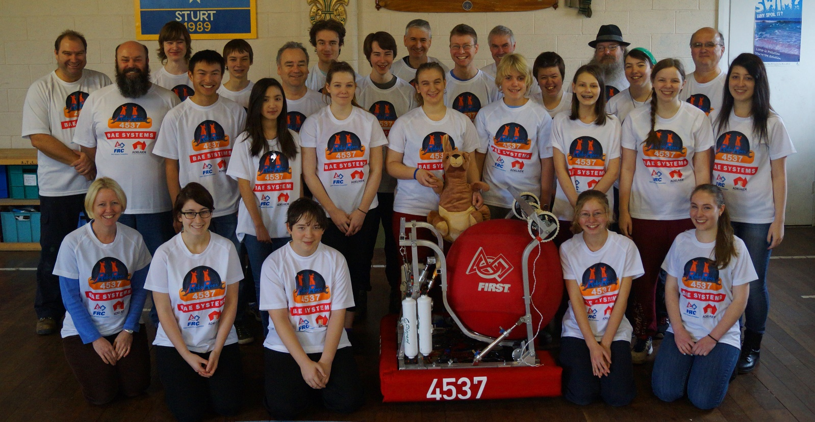
NEXT EVENTS

AVCon- July 19th & 20th:

Science Alive- August 9th & 10th RoboRoos Open Day- August 24th

